**Lab 7: PSpice Cadence Simulation**

**Lab Report by: Talal Jawaid**

**Lab Session: Wednesday**

**Due Date of the Lab: 3/14/18**

**Date(s) of the lab: 3/7/18**

**Lab partner(s): Sergio Zavala and Amrit Singh**

**Transient Analysis Circuit 1**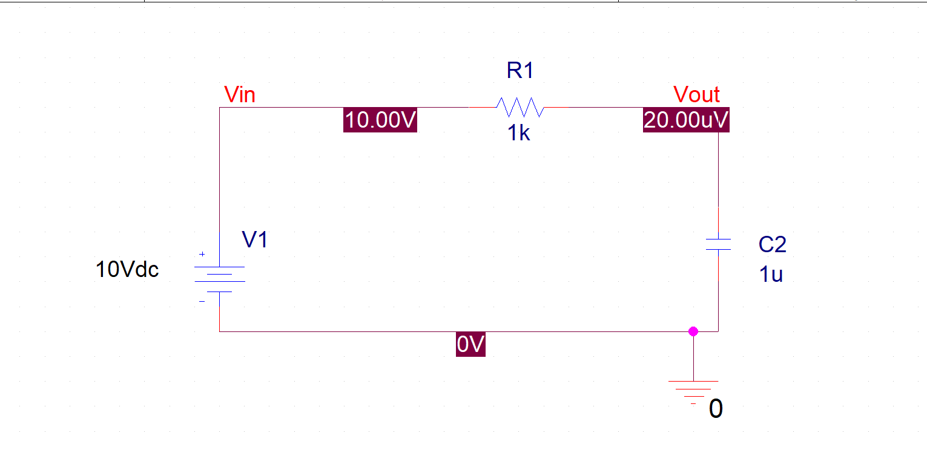

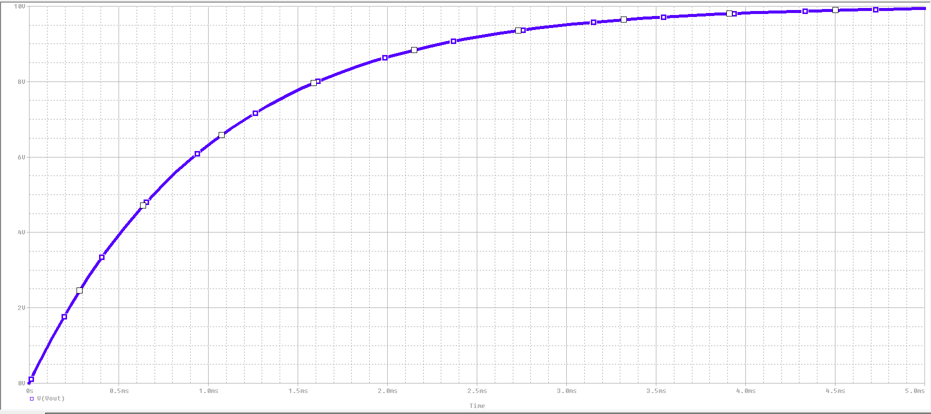

Time

**Transient Analysis Circuit 2**

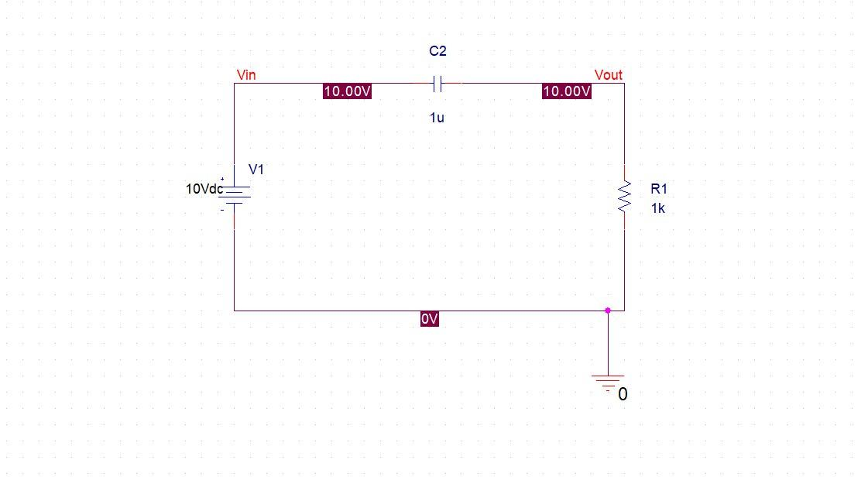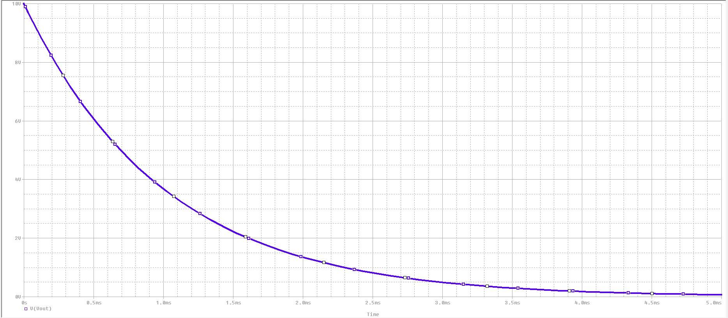

**AC Sweep Circuit 3**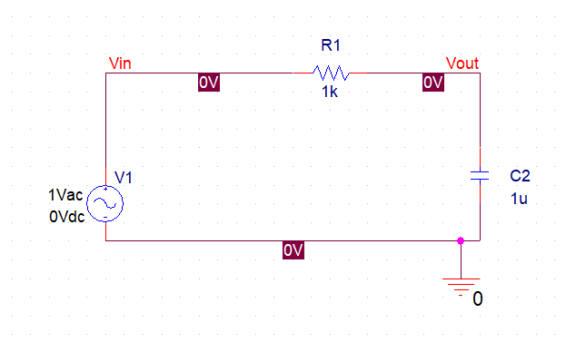

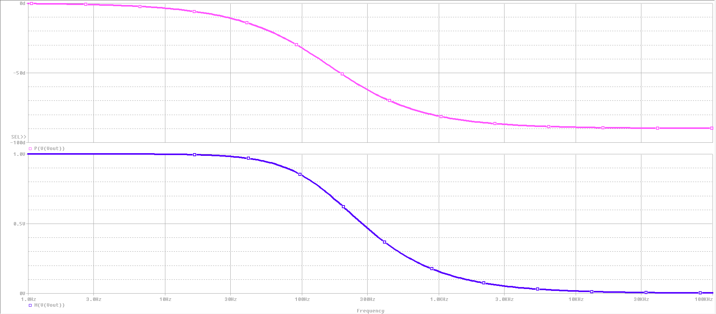

**AC Sweep Circuit 4**

